 **Assignment Cover Sheet**

|  |  |  |
| --- | --- | --- |
| **Student Information (For group assignment, please state names of all members)** | | **Grade/Marks** |
| **Name** | **ID** |  |
| Ni Putu Zara Athifa Wijana | E1800193 |  |
| Muthia Kartika Putri | E1800189 |  |
|  |  |  |
|  |  |  |
|  |  |  |
|  |  |  |
|  |  |  |

|  |  |  |
| --- | --- | --- |
| **Module/Subject Information** | | **Office Acknowledgement** |
| **Module/Subject Code** | BIT302 |  |
| **Module/Subject Name** | Software Engineering |  |
| **Lecturer/Tutor/Facilitator** | Seetha Letchumi |  |
| **Due Date** | November 5, 2021 |  |
| **Assignment Title/Topic** | Assignment 1 PCVS |  |
| **Intake (where applicable)** |  |  |
| **Word Count** | 5957 | **Date/Time** |

**Declaration**

* I/We have read and understood the Programme Handbook that explains on **plagiarism**, and I/we testify that, unless otherwise acknowledged, the work submitted herein is entirely my/our own.
* I/We declare that no part of this assignment has been written for me/us by any other person(s) except where such collaboration has been authorized by the lecturer concerned.
* I/We authorize the University to test any work submitted by me/us, using text comparison software, for instances of plagiarism. I/We understand this will involve the University or its contractors copying my/our work and storing it on a database to be used in future to test work submitted by others.

Note: 1) The attachment of this statement on any electronically submitted assignments will be deemed to have the same authority as a signed statement.

2) The Group Leader signs the declaration on behalf of all members.

|  |  |
| --- | --- |
| Signature: Ni Putu Zara Athifa Wijana | Date: November 3, 2021 |
| E-mail: [zaraathifaa@gmail.com](mailto:zaraathifaa@gmail.com) |  |

|  |
| --- |
| **Feedback/Comments\*** |
| **Main Strengths** |
|  |
|  |
|  |
|  |
|  |
|  |
|  |
| **Main Weaknesses** |
|  |
|  |
|  |
|  |
|  |
|  |
|  |
| **Suggestions for improvement** |
|  |
|  |
|  |
|  |
|  |
|  |
|  |

|  |  |
| --- | --- |
|  | **Student acknowledge feedback/comments** |
|  |
| Grader’s signature | Student’s signature: |
| Date: | Date: |

Note:

1. A soft and hard copy of the assignment shall be submitted.
2. The signed copy of the assignment cover sheet shall be retained by the marker.
3. If the Turnitin report is required, students have to submit it with the assignment. However, departments may allow students up to **THREE** (3) working days after submission of the assignment to submit the Turnitin report. The assignment shall only be marked upon the submission of the Turnitin report.

*Use additional sheets if require

**Assignment 1**

**BIT302**

**MY Private Vaccine: A Web Based Private Covid-19 Vaccination System**



Ni Putu Zara Athifa Wijana (E1800193)

[zaraathifaa@gmail.com](mailto:zaraathifaa@gmail.com)

**as Team Leader**

Muthia Kartika Putri (E1800189)

[muthiakartika2 @gmail.com](mailto:awidyaandika@gmail.com)

**as Team Member**

2021

**TASK 1**

**Project Proposal**

**Page Of Content**

I. Overview 1

II. Project Aims 3

III. Project Objectives 3

IV. Project Scope 4

V. Project Schedule 6

VI. Technical Description of The Proposed System 10

VII. Risk Management Plan 13

VIII.Risk Management Matrix 14

References 15

# Overview

1. **Project Background and motivation**

The corona virus, also known as COVID-19, was officially declared a pandemic in 2020, indicating that it has spread widely throughout the world. Corona virus infection, also known as COVID-19, is caused by SARS-CoV-2 virus, a type of virus that infects the respiratory system. As of October 11, 2021, there were a total of 238,652,927 confirmed cases worldwide and 4,867,295 deaths from COVID-19. COVID-19 caused 2,332,221 confirmed cases and 27,265 deaths in Malaysia alone.

To put an end to this pandemic, the World Health Organization (WHO) has instructed that all countries provide COVID-19 vaccinations to all their citizens. Vaccination is the administration of vaccines to the body that can stimulate the formation of the immune system. Vaccination is a highly reliable primary prevention strategy for diseases that can be prevented by vaccination. It is hoped that with the proper vaccination procedure, optimal immunity will be obtained. This vaccination is part of WHO's effort to halt the spread of the COVID-19 virus and bring the pandemic to an end, allowing all citizens of the world to resume their normal activities.

The Malaysian government has immediately begun to vaccinate their citizen since January 5, 2021, so that all of them can go about their daily lives and also reducing the number of cases of COVID-19 spread and deaths. Due to the high level of interest in vaccinating among Malaysian citizens, the government allows private health centers to provide and administered vaccines, particularly to the people who wants to choose the type of vaccine they get. The condition of that decision is that the vaccination administered must be recorded in the national vaccine database.

Therefore, we, Ni Putu Zara Athifa Wijana and Muthia Kartika Putri will help private health centers by creating a website-based application called MY Private Vaccine. to record vaccination data that has been given to the public and will be recorded directly into the national vaccination committee database.

1. **Project Customer/User**

This website is created to be used by the following users:

• Patients here are the general public

• Health Administrator

1. **Project Deliverables**

This project will make it easier for people who want to register to carry out COVID-19 vaccinations and choose the type of vaccine they receive independently. On the other hand, this project can also help private healthcare administrators to record the number of people who will carry out vaccinations independently, and later the data can be recorded in the database of the national vaccination committee. This project is a new product that will be developed to assist the implementation of vaccination in Malaysia.

1. **Project Estimate Cost**

The project begins on October 4, 2021 and ends on December 24, 2021, with a total working time of 496 hours over the course of 62 days. This project has two members: one as the team leader and one as a team member, both with a labor cost of RM6/hour. This project's total labor cost is estimated to be RM5952. The cost of internet and electricity bills across the project is estimated to be RM450, with a total cost of RM6402. Unless there are changes that cannot be predicted at this time for the future, the costs mentioned are more or less certain.

1. **Project Duration**

This project will start on October 4, 2021, until December 24, 2021, with an estimated construction time of 11 weeks. This depends on the situation and conditions that we will face during the process of working on this project.

# Project Aims

The purpose of this project is to help private healthcare centers to record and monitor the number of patients who want to carry out vaccinations independently and later the data will be directly recorded into the database of the national vaccine committee. As for patients who are the general public, this project can assist them in participating in the vaccination program by registering independently, and also the patients can choose the type of vaccine they want to use for this COVID-19 vaccination.

# Project Objectives

1. Helping private healthcare to record and monitor the number of patients who will carry out vaccinations.
2. Helping private healthcare to send data on patient recipients of vaccines to the database of the national vaccine committee
3. Helping the general public to carry out self-vaccination and can make it easier for them to choose the type of vaccine to be used.

# Project Scope

|  |
| --- |
| **Project Title:** MY Private Vaccine  **Date:** October 10, 2021  **Prepared by:** Ni Putu Zara Athifa Wijana |
| **Project Justification:**  MY Private Vaccine is a system designed to record vaccinations administered to the public by private health centers in a database maintained by the national vaccination committee. PCVS will be accessed through a login system and will automatically differentiate between patients and Healthcare Administrator. After logging into the system, MY Private Vaccine will allow patients to select the type of vaccine and submit a vaccination schedule that they want. For Healthcare Administrator, MY Private Vaccine will enable them to record new vaccine batches and view vaccine information, confirm both vaccine type and vaccination schedules, and record vaccine schedules and types that have been managed. |
| **Product Requirements:**   1. Require sign up and log in to the system for both patients and healthcare administrator 2. Allow patients to choose both vaccine type and appointment date 3. Allow healthcare administrator to record new vaccine batch, view vaccine information, confirm patient’s request, and record the administered vaccination to the national committee database. 4. User friendly system |
| **Summary of Project Deliverables**  **Project management-related deliverables:**  Project plan, project overview, project aims, project objectives, project scope, WBS, milestones, gantt chart, risk management plan, requirements specification document, final report, and other document related to the project.  **Product-related deliverables:**  **In Scope:**   1. Differentiate user between patients and healthcare administrator 2. Customize the features of the website based on the user role (patients or healthcare administrator) 3. Record patients appointment date, vaccine type, and place where they want to be vaccinated. 4. Vaccine administered will be record on the national database 5. Display currently available vaccine stock   **Out of Scope:**   1. Provide and store vaccine card 2. Payment within the system 3. Provide article related to COVID-19 |
| **Project Success Criteria:**  The MY Private Vaccine project determined a success if we can complete this project within the time and budget constraints that have been set. Furthermore, the project must meet all of the conditions and requirements listed and not diverge from the initial goal. More importantly, this project must be able to benefit the community. |

# Project Schedule

1. **WBS**
2. **Initiating**
   * + 1. Analyze Case
       2. Appoint Team Leader
       3. Specify Project Overview
       4. Specify Project Aims
       5. Specify Project Objectives
3. **Planning**
   * + 1. Create Project Scope
       2. Create Project Schedule
       3. Create WBS
       4. Create Milestones
       5. Create Gannt Chart
       6. Create Technical Description
       7. Create Risk Management Plan
       8. Examine Use Case
       9. Examine Class Diagram
       10. Examine Expand Use Case
       11. Examine SSD
       12. Examine Contract
       13. Create Rough Sketch of the Website
4. **Executing**
   * + 1. Design Website Appearance/front-end
       2. Design Website System/back-end
       3. Connect/configure front-end and back-end
5. **Monitoring**
   * + 1. Update Gantt Chart
       2. Testing
6. **Closing**
   * + 1. Final Report
       2. Final Presentation
       3. Project End
7. **Milestone**

|  |  |  |  |  |  |
| --- | --- | --- | --- | --- | --- |
| **Schedule** | **Start Date** | **End Date** | **Days Estimated** | **Status** | **In Charge** |
| **Initiating** | | | | | |
| Appoint Team Leader | October 4, 2021 | October 4, 2021 | 1 day | Complete | All |
| Analyze Case | October 4, 2021 | October 5, 2021 | 2 day | Complete | All |
| Specify Project Overview | October 6, 2021 | October 11, 2021 | 4 days | Complete | Muthia Kartika |
| Specify Project Aims | October 6, 2021 | October 11, 2021 | 4 days | Complete | Muthia Kartika |
| Specify Project Objectives | October 6, 2021 | October, 11 2021 | 4 days | Complete | Muthia Kartika |
| **Planning** | | | | | |
| Create Project Scope | October 11, 2021 | October 12, 2021 | 2 days | Complete | Zara Athifa |
| Create Project Schedule | October 11, 2021 | October 12, 2021 | 2 days | Complete | Zara Athifa |
| Create WBS | October 11, 2021 | October 12, 2021 | 2 days | Complete | Zara Athifa |
| Create Milestones | October 13, 2021 | October 14, 2021 | 2 days | Complete | Zara Athifa |
| Create Gannt Chart | October 13, 2021 | October 14, 2021 | 2 days | Complete | Zara Athifa |
| Create Technical Description | October 11, 2021 | October 12, 2021 | 2 days | Complete | Zara Athifa |
| Create Risk Management Plan | October 12, 2021 | October 13, 2021 | 2 days | Complete | Zara Athifa |
| Examine Use Case | October 14, 2021 | October 18, 2021 | 3 days | Complete | All |
| Examine Class Diagram | October 14, 2021 | October 18, 2021 | 3 days | Complete | All |
| Examine Expand Use Case | October 18, 2021 | October 20, 2021 | 3 days | Complete | All |
| Examine SSD | October 21, 2021 | October 28, 2021 | 3 days | Complete | All |
| Examine Contract | October 26, 2021 | October 28, 2021 | 3 days | Complete | All |
| Create Rough Sketch of the Website | October 28, 2021 | November 1, 2021 | 3 days | Complete | All |
| **Executing** | | | | | |
| Design Website Appearance -front end- | November 2, 2021 | December 20, 2021 | 35 days | Proceeding | All |
| Design Website System -back end- | November 2, 2021 | December 20, 2021 | 35 days | Proceeding | All |
| Connect/configure frontend and backend | December 13, 2021 | December 17, 2021 | 5 days | - | All |
| **Monitoring** | | | | | |
| Update Gantt Chart | October 11, 2021 | December 25, 2021 | 56 days | - | Zara Athifa |
| Testing | November 2, 2021 | December 20, 2021 | 35 days | - | All |
| **Closing** | | | | | |
| Final Report | December 20, 2021 | December 22, 2021 | 3 days | - | All |
| Final Presentation | December 20, 2021 | December 22, 2021 | 3 days | - | All |
| Project Finished | December 23, 2021 | December 23, 2021 | 1 day | - | All |

1. **Gantt Chart**

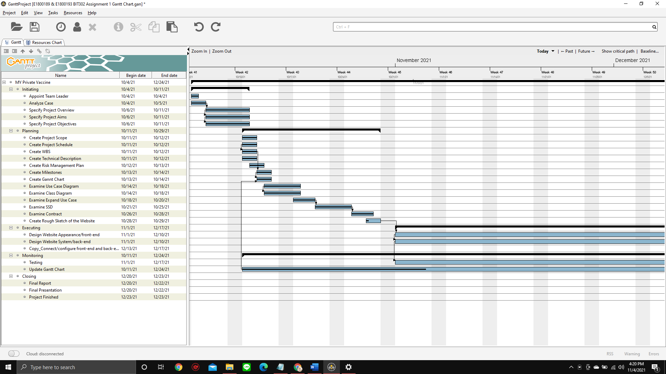

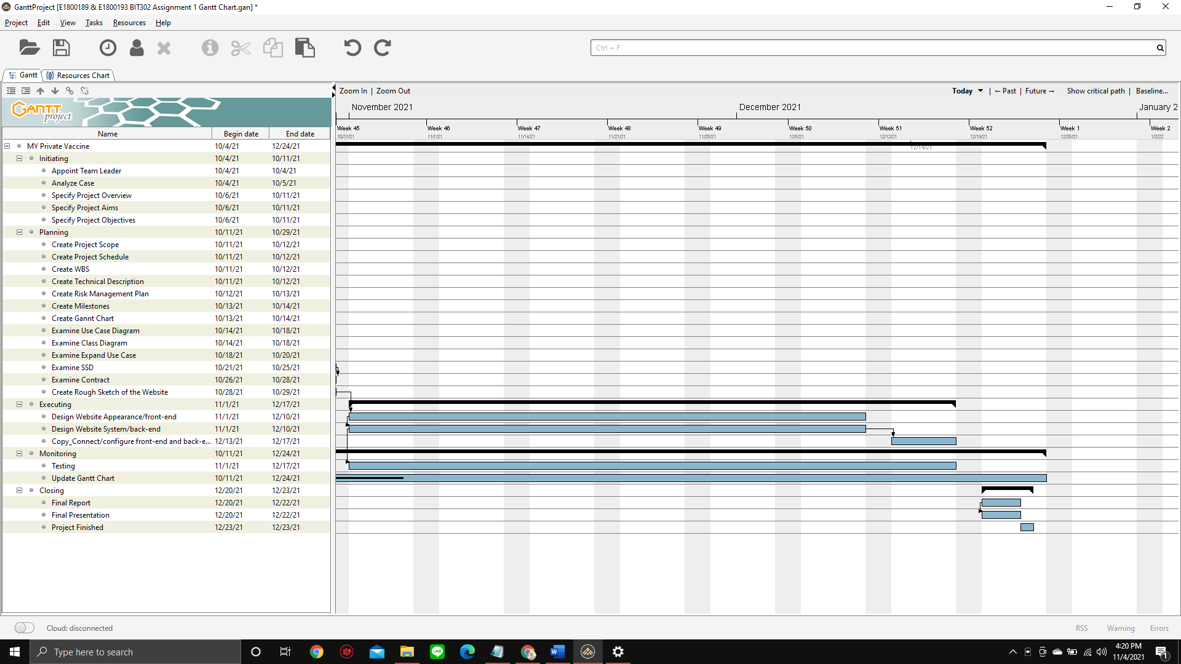

# Technical Description of The Proposed System

1. **Development Platform**

* **Methods**

We chose the waterfall approach as the method for working on this project. We choose the waterfall methodology because we have a clear target time for project completion and the needs that must exist in this project have already been determined. The sequential and systematic phases of the process are highlighted in this waterfall methodology. The development model can be compared to a waterfall, in which each stage is completed in order from top to bottom. We began working on this project by gathering and evaluating various data and then discussing the specific requirements among team members. Furthermore, we use this data as a guide for building the complete system, including front-end and back-end. The following step is to put the program code into action, which is followed by the integration process and comprehensive testing of the system. The operation and maintenance steps will bring this waterfall method to a finish.

* **Software**

1. Microsoft Word

Microsoft Word is used to work on documents related file of the project proposal also the final report which we will submit at the end of the project.

1. Microsoft Project

Microsoft Project is used to make a Gantt Chart which is part of the project proposal.

1. Microsoft PowerPoint

Microsoft PowerPoint is used to make any kind of presentation required for this project.

1. Visual Paradigm Online

Visual Paradigm Online is used to make the sequence diagram of the expanded use cases of the project.

1. PhpStorm

PhpStorm is used as a IDE because it provides editors fast code analysis, error prevention, and automatic refactoring for PHP, HTML, CSS, and JavaScript that are useful for this project.

1. Laravel

Laravel is used as a PHP framework to maximize the use of PHP for this project.

1. Bootstrap

Bootstrap is used as a framework for the front end which makes CSS development easy for this project.

1. jQuery

jQuery is used as a JavaScript library to manage the interaction between JavaScript and HTML for this project.

1. MySQL

MySQL is a based SQL DBMS or Database Management System that is used to store the data entered by the user into the database for this project.

1. Google Chrome

Google Chrome is used to do research and also to test the website that is being developed.

1. Adobe Photoshop

Adobe Photoshop is used to make design for the website

1. Git and GitHub

Git and GitHub are used to help team members in compiling script code, because it includes a VCS System that records changes made to script code. This implies that all code history will be available on each team member's computer, making it easy to combine tasks for this project.

* **Programming Language**

1. HTML

HTML is a programming language used to determine the structure of the website’s contents for this project.

1. CSS

CSS is a programming language that will be used to design website’s appearance for this project..

1. PHP

PHP is a server-side programming language that allows for database connectivity and a variety of user interactions in this project.

1. JavaScript

JavaScript is a programming language for creating interactive, responsive webpages and managing user interaction for this project.

* **Hardware**

1. Laptop

Laptop is the main hardware that we used to develop both this project proposal and the website itself.

1. Mobile Phones

Mobile Phones are used for team members to communicate with each other outside meeting hours.

1. **Demonstration Platform**

* **Software**

1. Microsoft PowerPoint

Microsoft PowerPoint is used to show the first and second presentation of this project.

1. Google Chrome

Google Chrome is used to demonstrate the final product which is MY Private Vaccine website.

* **Hardware**

1. Laptop

Laptop is the main hardware that we used to demonstrate both this project presentation through Microsoft PowerPoint and the website through Google Chrome.

# Risk Management Plan

|  |  |  |  |  |  |  |  |  |  |  |
| --- | --- | --- | --- | --- | --- | --- | --- | --- | --- | --- |
| **No.** | **Risk** | **Risk Category** | **Risk Description** | **Triggers** | **Probability** | **Impact** | **Grade** | **Risk Owner** | **Mitigation** | **Contingency** |
| **1.** | Working on certain tasks takes longer than scheduled | Scheduling Risk | When an already estimated task duration takes longer than expected, preventing another task to start on time. | The person in charge of the task procrastinates/is unable to complete the task due to illness, a lack of time, or other factors. | M | M | 4 | all | During the project work process, each team member must be able to manage and divide time effectively. | The person in charge of the task must speed up the process, with or without the assistance of other team member. |
| **2.** | Miscommunication between team member | Communication Risk | When there is a miscommunication among team members that causes team members to work on the projects with different intent and purpose. | Lack of communication or meetings between team members that are conducted either offline or online. | M | H | 6 | all | Team members must conduct meeting and communicate frequently on a regular basis, the meeting can be done both online or offline meetings. | Team members must immediately hold a calm discussion in which each member expresses their opinion and seeks the most appropriate solution so that the problem can be resolved as soon as possible. |
| **3.** | Product results do not meet requirements | Operational Risk | When the final product is found to be in violation of the project's requirements | Team members that are unfamiliar with project work due to a lack of relevant experience | M | M | 4 | all | Before starting the project, team member must conduct a lot of research | Team member must spend more time on research before the project due |
| **4.** | Cost Overruns | Budget Risk | Potential cost overruns resulting from inaccurate cost estimates | Cost estimates that are far too low | L | L | 1 | all | Before starting the project, team member must thoroughly discuss the cost estimate. | Team member must be able to cut costs by eliminating unnecessary expenses. |

# Risk Management Matrix

|  |  |  |  |  |
| --- | --- | --- | --- | --- |
| PROBABILITY |  | IMPACT | | |
|  | Low | Medium | High |
| High | 3 | 6 | 9 |
| Medium | 2 | 4 | 6 |
| Low | 1 | 2 | 3 |

# References

Denison-Grimes, K. (2019, May 17). *When to Use Waterfall vs. Agile*. Macadamian. <https://www.macadamian.com/learn/when-to-use-waterfall-vs-agile/>

Shah, K. (2021, April 16). *Risk Management in Software Development: A Complete Guide*. Third Rock Techkno. <https://www.thirdrocktechkno.com/blog/risk-management-in-software-development-a-complete-guide/>

Westland, J. (2021, January 14). *Work Breakdown Structure (WBS): The Ultimate Guide with Examples*. ProjectManager.Com. <https://www.projectmanager.com/work-breakdown-structure>

*COVID-19 CORONAVIRUS PANDEMIC*. (n.d.). Worldometer. Retrieved October 11, 2021, from <https://www.worldometers.info/coronavirus/>

**TASK 2**

**Requirement Specification**

**Page of Content**

I. Functional and Non-Functional Requirements 1

A. Functional Requirements 1

B. Non-Functional Requirements 2

II. Modeling Requirements 3

A. Use Case Diagram Analysis 3

B. Class Diagram Analysis 4

C. Expanded Use Case, SSD, and Contracts 6

1. Sign Up 6

2. Login 9

3. Record New Vaccine Batch 11

4. Request Vaccination Appointment 13

5. Logout 16

6. View Vaccine Batch Information 18

7. Confirm Vaccination Appointment 21

8. Record Vaccination Administered 23

III. Task Division 25

Reference 27

# Functional and Non-Functional Requirements

## Functional Requirements

1. **Healthcare Administrator**

* A menu to sign up to the system
* A menu to login to the system
* Username/ID and password verification in login menu
* Healthcare Administrator dashboard will be displayed after successfully login to the system
* Record New Vaccine Batch menu to record new vaccine batch data from patient
* View Vaccine Batch Information menu to show the information about vaccine batch that has been recorded
* Record Vaccination Administered menu to record new data from patient who wants to do vaccinate
* Confirm Vaccination appointment menu to confirm patient vaccination appointment
* Log out button to exit/logout from the system

1. **Patient**

* A menu to sign up to the system
* A menu to login to the system
* Username/ID and password verification in login menu
* Patient dashboard will be displayed after successfully login to the system
* Request Vaccination appointment menu to make a new request for vaccination appointment.
* Log out button to exit/logout from the system

## Non-Functional Requirements

1. **Availability**

This system will be available for the majority of the time, with an unplanned downtime of no more than 5 hours per case. This system is also easily accessible to all citizens with internet and mobile device access.

1. **Compatibility**

This system must be functioning properly in a variety of browsers, or at least four of the most commonly used browsers, such as Chrome, Edge, Mozilla Firefox, and Safari.

1. **Performance**

The system must be able to quickly return the results that the user has requested. MY Private Vaccine should respond to user actions such as login, opening a new page, filling out data, and so on as quickly as possible and should not make the user wait longer than 10 seconds to access one of the menus

1. **Reliability**

This system will be used for an indefinite period of time, and it must be reliable during that time so that the chance of critical failures occurring during normal or heavy usage conditions remains below 10%.

1. **Security**

This system will have to be guaranteed safe so that it can avoid data breaches that compromise user privacy, all user data kept within the system will be protected against malware and any type of unauthorized access.

1. **Usability**

This system must be user-friendly, with simple navigation and design to avoid confusing users, including those who are unfamiliar with electronics.

# Modeling Requirements

## Use Case Diagram Analysis

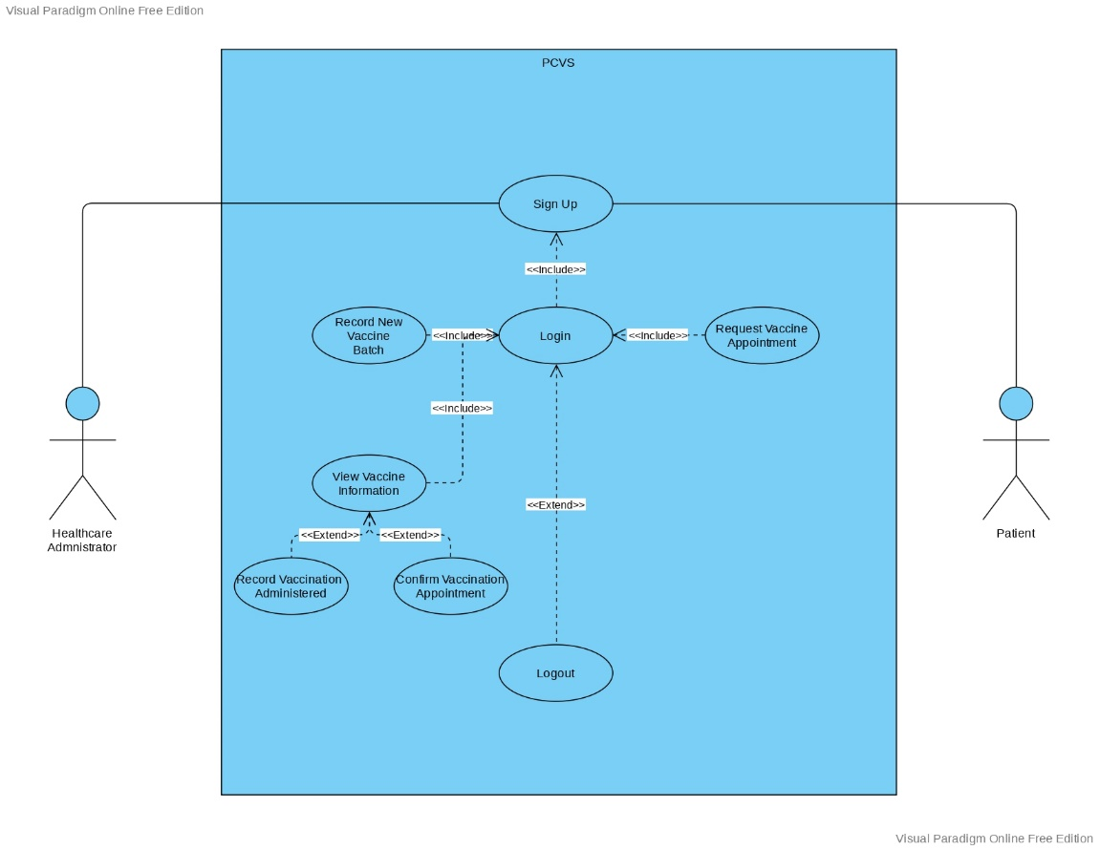

The use case flow, which comprises of eight use case, is depicted in the image above. There are two actors in the use case: Patients and Healthcare Administrator. Sign Up, Sign In, Request Vaccine Appointment, and Logout are the four use case of Patient user. Sign Up, Sign In, Record New Vaccine Batch, View Vaccine Information, Confirm Vaccine Appointment, Record Vaccine Administered, and Logout are the use case of a Healthcare Administrator user.

The phrases <include> and <extend> in the use case above serve as a relationship between two use cases. The term <include> denotes that a use case functionality is wholly dependent from another linked (base) use case. In the other hand, when a condition is met, the term <extend> indicates that a use case is an optional addition to another linked (base) use case. Use Case Recor Vaccine Administered is an extension of use case View Vaccine Information, as seen in the image, which implies that when a user (in this case, Healthcare Administrator) wants to view vaccine information, they do not need to perform Record Vaccine Administrator use case as well. Meanwhile use case with the arrow that has words <include> with the Login use case indicate that if the user(in this case both the Patient and Healthcare Administrator) wants to access all of the other use cases, they must first finish the Login process/use case.

## Class Diagram Analysis

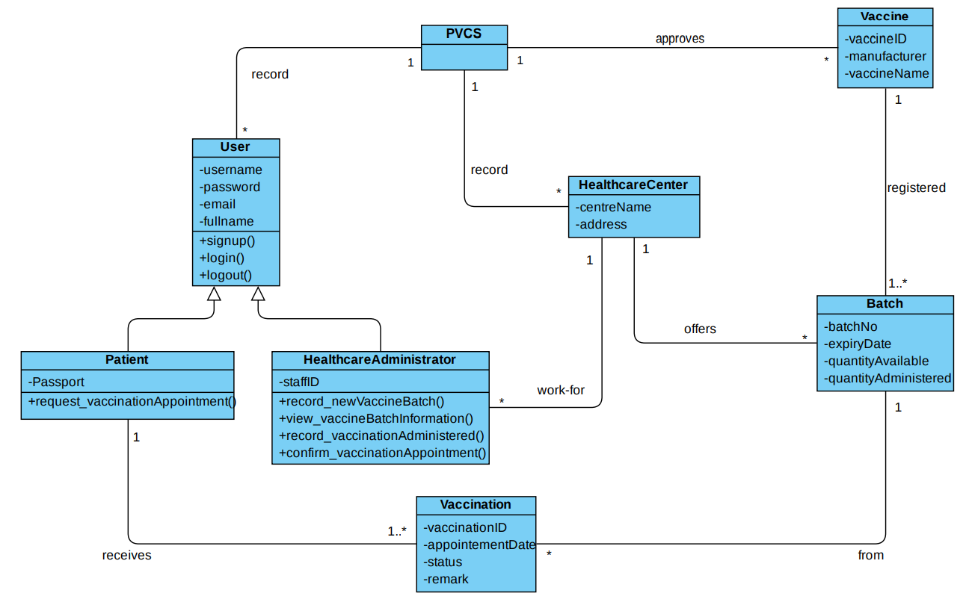

This project has 8 classes, those are PVCS, User, Patient, HealthcareAdministrator, HealthcareCenter, Vaccine, Batch, and Vaccination. PVCS class is the system. User class is parent class for Patient and HealthcareAdministrator, it has 4 attributes and 3 operations. Patient class inherits to User class, it has an attribute and 1 operation. HealthcareAdministrator class inherits to User class, it has an attribute and 4 operations. As the child class from User, both Patient and HealthcareAdministrator class can access the attributes and operations in User class. PVCS as system class has one to many relationships with User and Vaccine class, meaning that in the PVCS system there could be many Users recorded and Vaccine approved.

HealthcareCenter class has one to many relationships with HealthcareAdministrator and Batch, also HealthcareCenter class has many to one relation with PVCS class. It means that in one Healthcare Center there could be many Healthcare Administrator and Batch, also in one Healthcare Center there will be one PVCS. Batch class has one to many relations with Vaccination class and it has one or many relations with Vaccine class. It means that in one Batch came from many Vaccination, and in one or many Batch could be one Vaccine registered. Vaccination class has one or many relations with Patient, meaning that one Patient could receive one or many Vaccination.

## Expanded Use Case, SSD, and Contracts

**Student Name & ID: Ni Putu Zara Athifa Wijana & E1800193**

### Sign Up

* Expanded Use Case

|  |  |  |
| --- | --- | --- |
| **Use Case 1** | Sign Up | |
| **Goal** | To make it possible for new users (patients and healthcare administrators) to create an account. | |
| **Actor** |  | |
| * **Primary** | Healthcare administrator | |
| * **Secondary** | Patient | |
| **Trigger** | A new user wants to sign up to PCVS | |
| **Typical Course of Events** | | |
| **Actor Action** | | **System Response** |
| 1. This use case begins when a healthcare administrator wants to join up for PCVS as a healthcare administrator | |  |
| 1. The healthcare administrator chooses the healthcare center's centreName. | | The healthcare center's centerName and centerAddress are displayed. |
| 1. The healthcare administrator signs up by providing a username, password, full name, email address, and staffID. | | The healthcare administrator account is created for the healthcare center's healthcare administrator. |
| **Alternative Course of Events** | | |
| 2a: skip to 3a if the user is a patient.  2b: if the healthcare center isn't listed, the administrator fills in the name and address of the facility.  3a: the patient provides his or her username, password, email address, identification card or passport number, and a pat | | |

* SSD

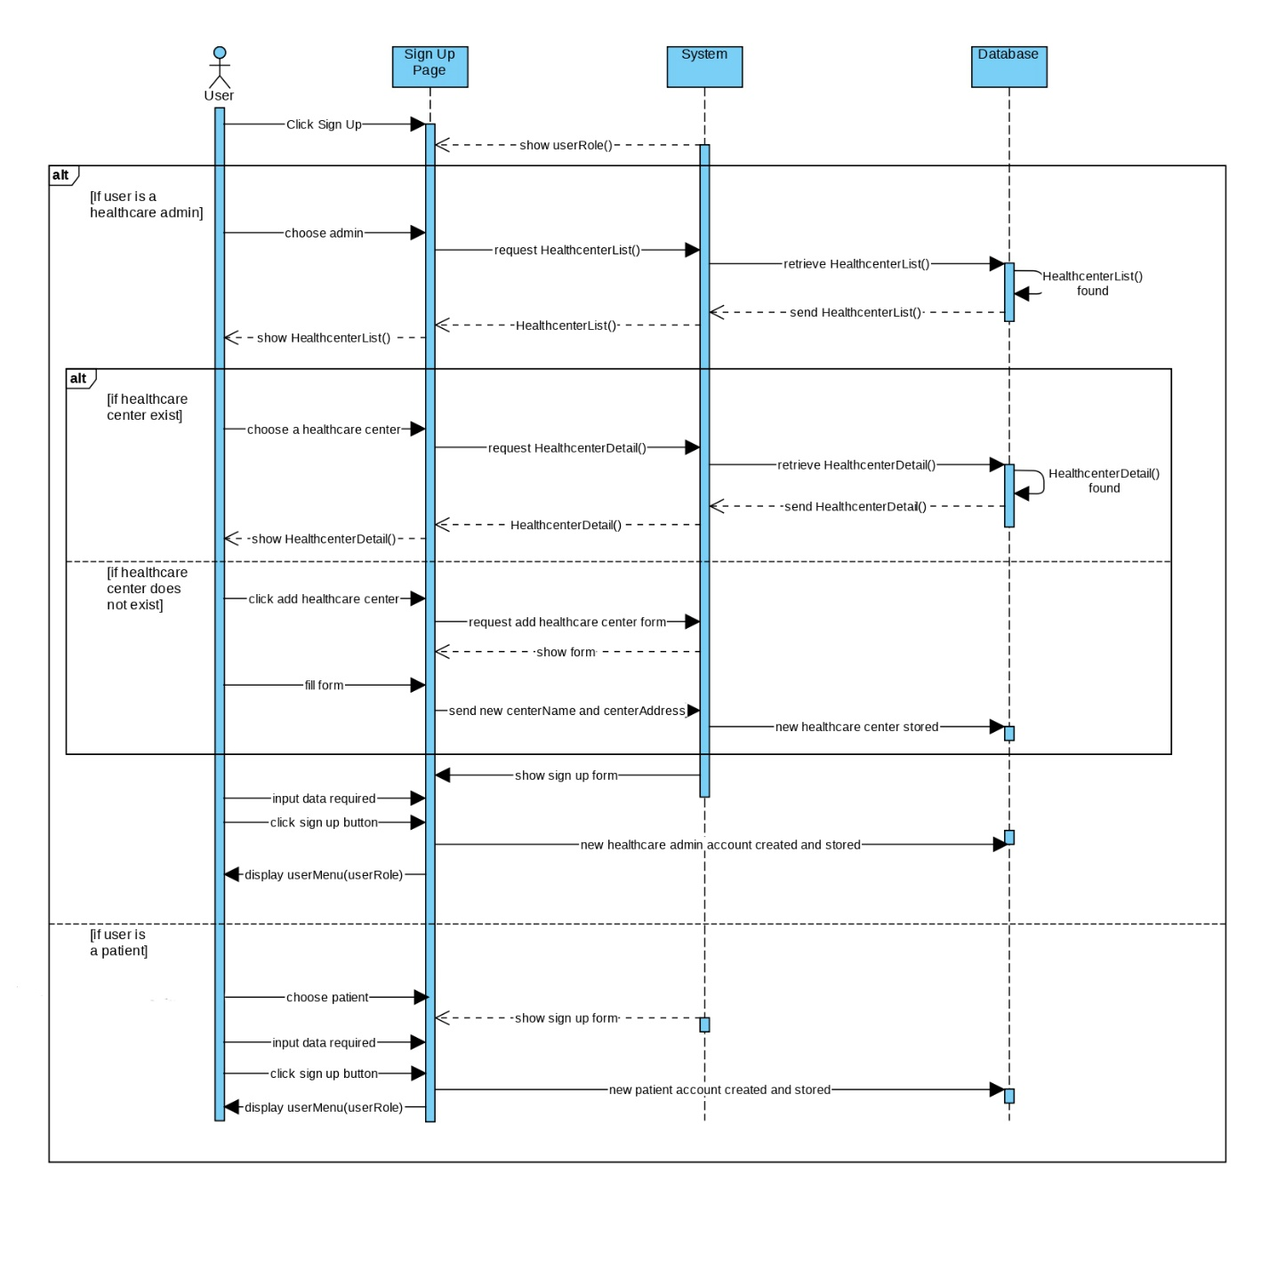

* Contracts

|  |  |
| --- | --- |
| **Cross References** | **Sign Up for Patient** |
| Operation | Signup(username, password, email, fullName, ICPassport) |
| Responsible | To allow potential patient to sign up |
| Pre-conditions | * A valid and active email exist * ICPassport registered |
| Post-conditions | * Patient account created * Directed to patient menu page |
| **Cross References** | **Sign Up for Healthcare Administrator** |
| Operation | Signup(username, password, email, fullName, staffID) |
| Responsible | To allow potential healthcare administrator to sign up |
| Pre-conditions | * A valid and active email exist * Registered to a healthcare centre as a staff with valid staffID   **If** a healthcare centre is not listed  **then** add centerName and centerAddress |
| Post-conditions | * Healthcare administrator account created * Directed to healthcare administrator menu page |

### Login

* Expanded Use Case

|  |  |  |
| --- | --- | --- |
| **Use Case 2** | Login | |
| **Goal** | Allow existing PCVS users (patients and healthcare administrators) to log in. | |
| **Actor** |  | |
| * **Primary** | User (patients and healthcare administrator) | |
| * **Secondary** | - | |
| **Trigger** | A existing user wants to sign in to the PCVS | |
| **Typical Course of Events** | | |
| **Actor Action** | | **System Response** |
| 1. this use case begins when a user (patients or healthcare administrators) wishes to sign in to PCVS. | |  |
| 1. The user (patients and healthcare providers) inputs their login and password. | | According to the user's role, the system will route them to their dashboard. |
| 1. The user (patients and healthcare administrator) enters the username and password | | The system will redirect the user to their dashboard according to their role |
| **Alternative Course of Events** | | |
| 3a: If the user forgets their password, the system will remind them to type it in again. | | |

* SSD

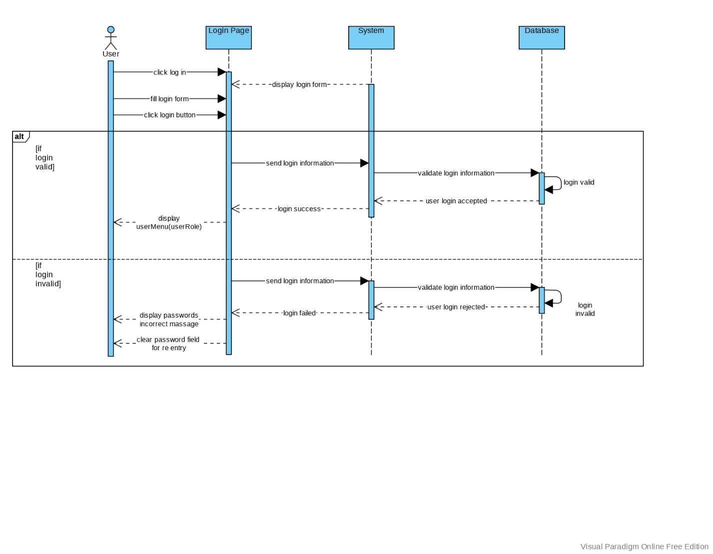

* Contracts

|  |  |
| --- | --- |
| **Cross References** | **Login** |
| Operation | Login(username, password) |
| Responsible | allow the user to access menu and feature according to the user's role |
| Pre-conditions | * Username and password should valid |
| Post-conditions | **If** login valid   * Directed to healthcare administrator/patient menu page * Login session started   **else**   * Clear password field for re-entry * Login session pending |

### Record New Vaccine Batch

* Expanded Use Case

|  |  |  |
| --- | --- | --- |
| **Use Case 3** | Record New Vaccine Batch | |
| **Goal** | Allowing a healthcare administrator to list available vaccine batches at a facility. | |
| **Actor** |  | |
| * **Primary** | Healthcare administrator | |
| * **Secondary** | - | |
| **Trigger** | The healthcare center has received a new batch of vaccines | |
| **Typical Course of Events** | | |
| **Actor Action** | | **System Response** |
| 1. When a healthcare administrator wants to record that a new batch of vaccine is available, this use case begins. | |  |
| 1. With their username and password, the healthcare administrator logs in. | | The name of the healthcare facility is displayed. |
| 1. The vaccineID is chosen by the healthcare administrator. | | The vaccine's maker and name are displayed. |
| 1. The batch number, expiration date, and number of dosages available are all entered by the healthcare administrator. | | The vaccine's batch number and the healthcare center's address are both recorded. |
| **Alternative Course of Events** | | |
|  | | |

* SSD

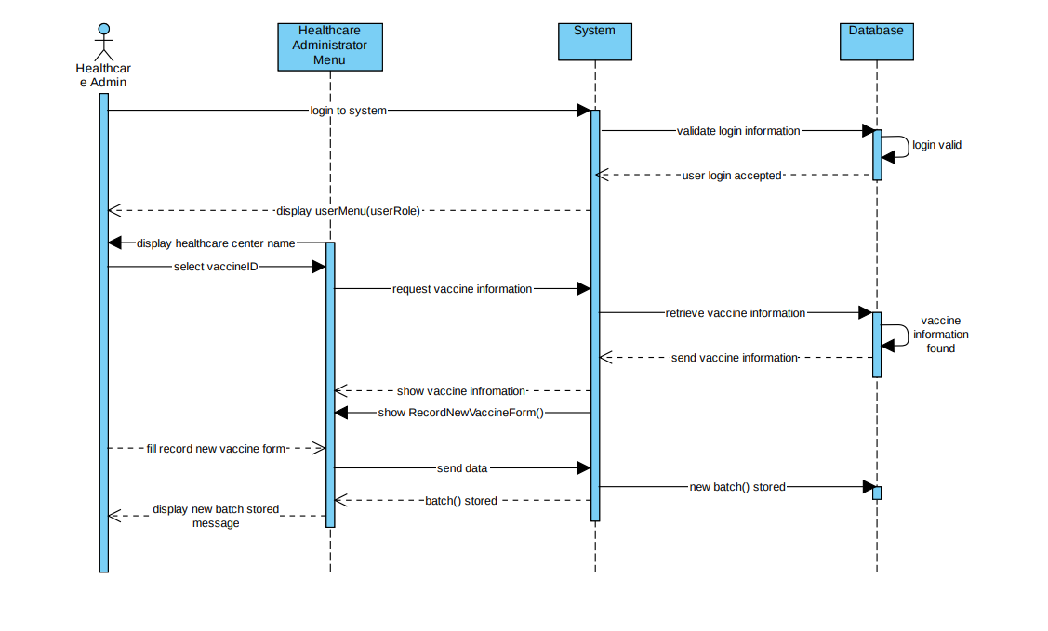

* Contracts

|  |  |
| --- | --- |
| **Cross References** | **Record new vaccine batch** |
| Operation | Login(username, password) |
| Responsible | allow healthcare administrator to access menu and feature |
| Pre-conditions | * Username and password should valid |
| Post-conditions | * Directed to healthcare administrator menu page * Login session started |
| **Cross References** | **Record new vaccine batch** |
| Operation | RecordNewVaccineBatch() |
| Responsible | Allow healthcare administrator to record new vaccine batch |
| Pre-conditions | * New vaccine batch number, expiry date and the quantity of doses should available |
| Post-conditions | * New batch of vaccine recorded * Display success message |

### Request Vaccination Appointment

* Expanded Use Case

|  |  |  |
| --- | --- | --- |
| **Use Case 4** | Request Vaccination Appointment | |
| **Goal** | Allowing the patient to schedule a vaccination appointment. | |
| **Actor** |  | |
| * **Primary** | Patients | |
| * **Secondary** | - | |
| **Trigger** | A patient wants to request an appointment for a vaccination. | |
| **Typical Course of Events** | | |
| **Actor Action** | | **System Response** |
| 1. When a patient requests a vaccination appointment, the use case begins. | |  |
| 1. The patient chooses to see what vaccines are available. | | The names of vaccines and their manufacturers are listed. |
| 1. The needed vaccine is recorded by the patient. | | A list of healthcare centers supplying this vaccine is displayed, along with their names and addresses. |
| 1. To view, the patient chooses a healthcare facility. | | The vaccine batch that has a sufficient quantity and has not yet expired is displayed. |
| 1. Patients submit their account and password to request an appointment in the system. | | The whole name of the patient is displayed. |
| 1. A batch is chosen by the patient. For a vaccine batchNo. | | The expiration date as well as the quantity available are displayed. The available quantity is determined by the number of pending and administered vaccinations. |
| 1. Patients choose a new date to request an appointment. | | For a new vaccine, a vaccinationID id is generated. The vaccination status is set to "pending," and the vaccination for the patient and batch is prepared. |
| **Alternative Course of Events** | | |
| 4a: if no acceptable batches are available, the patient may repeat lines 3 and 4.  7a: allow the patient to choose another date if the appointment is after the batch expiry date. | | |

* SSD

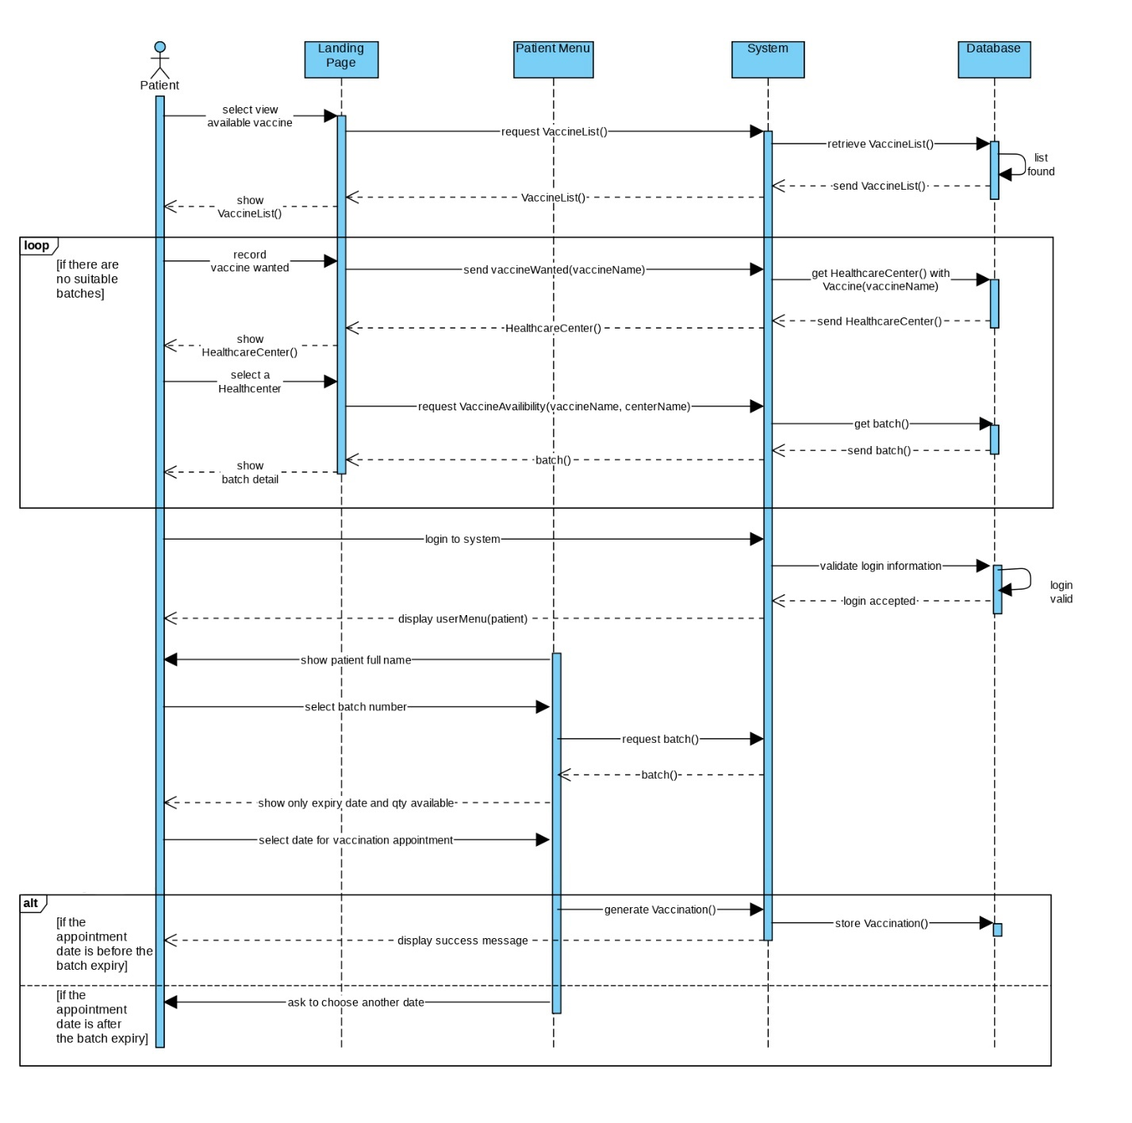

* Contracts

|  |  |
| --- | --- |
| **Cross References** | **Request vaccination appointment** |
| Operation | ViewVaccineAvailability() |
| Responsible | To allow patient view vaccine availability |
| Pre-conditions | * Patient already on the landing page |
| Post-conditions | * List of available vaccine shown * List of healthcare centre provide vaccine chosen shown * Vaccine batch detail shown   **If** no suitable batches found  **Then** patient repeat searching process |
| **Cross References** | **Request vaccination appointment** |
| Operation | Login(username, password) |
| Responsible | allow patient to access menu and feature |
| Pre-conditions | * Username and password should valid |
| Post-conditions | * Directed to patient menu page * Login session started |
| **Cross References** | **Request vaccine appointment** |
| Operation | RequestVaccinationAppointment() |
| Responsible | allow patient to request vaccination date and healthcare centre |
| Pre-conditions | * Patient fullName displayed * Batch number selected * Date selected   **If** date selected after batch expiry date  **Then** patient select another date |
| Post-conditions | * vaccinationID generated * display success message |

### Logout

* Expanded Use Case

|  |  |  |
| --- | --- | --- |
| **Use Case 5** | Logout | |
| **Goal** | To allow user (patients and healthcare administrator) to exit the system | |
| **Actor** |  | |
| * **Primary** | Patients and healthcare administrator | |
| * **Secondary** | - | |
| **Trigger** | A user (a patient or a healthcare administrator) wishes to exit the PCVS. | |
| **Typical Course of Events** | | |
| **Actor Action** | | **System Response** |
| 1. The use case begins when a user (patients/healthcare administrators) is already logged into the system and wishes to log out. | |  |
| 1. Patients and healthcare administrators log out by clicking the logout button. | | A logout confirmation message will be displayed by the system. |
| 1. The user (patients and healthcare administrators) clicks on the yes button. | | The login session will be terminated, and the user will be returned to the home page. |
| **Alternative Course of Events** | | |
| 4a. If the user clicks the no button, the logout process will be terminated. | | |

* SSD

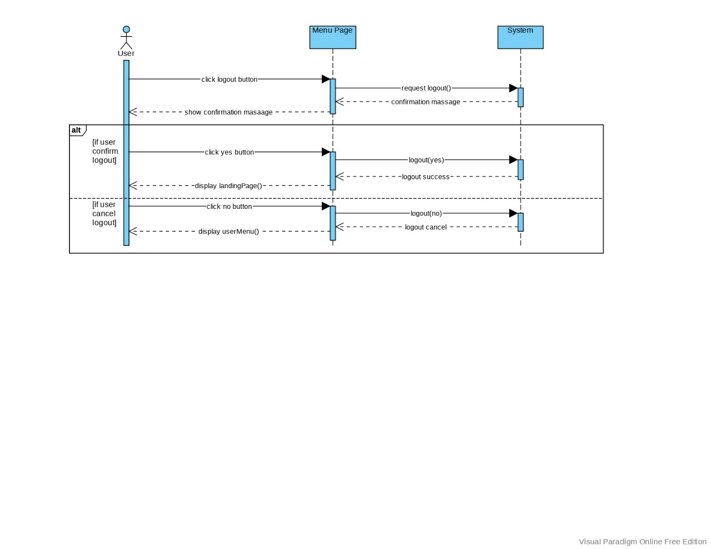

* Contracts

|  |  |
| --- | --- |
| **Cross References** | **Logout** |
| Operation | Logout() |
| Responsible | allow the user to logout from the system |
| Pre-conditions | * Session started * Click logout button |
| Post-conditions | **If** logout(yes)   * Click yes on the confirmation message * Login session ended   **else**   * Click no on the confirmation message * Back to user menu |

**Student Name & ID: Muthia Kartika Putri & E1800189**

### View Vaccine Batch Information

* Expanded Use Case

|  |  |  |
| --- | --- | --- |
| **Use Case 6** | **View Vaccine Batch Information** | |
| **Goal** | To view batch data for a healthcare facility | |
| **Actor** |  | |
| * **Primary** | Healthcare administrator | |
| * **Secondary** | - | |
| **Trigger** | The appointment request has been confirmed by a healthcare administrator. | |
| **Typical Course of Events** | | |
| **Actor Action** | | **System Response** |
| 1. This use case begins when a healthcare administrator wants to verify information about a vaccine batch. | |  |
| 1. The healthcare administrator logs in using a valid username and password. | | The name of the healthcare facility is displayed, along with a list of available vaccine batches organized by vaccine name and number of pending appointments. |
| 1. The healthcare administrator chooses a batchNo. | | The batch expiry date, as well as the number of available, pending, and administered vaccinations, are displayed. A list of vaccinations is displayed, along with the status and appointment date. |
| 1. The healthcare administrator chooses a vaccinationID. | | The information about the vaccine, vaccination batch, and patient is displayed. |
| 1. The healthcare administrator either manages the vaccination or logs out. | |  |
| **Alternative Course of Events** | | |
| 3a: The healthcare administrator has the option of viewing a different batch.  4a: The healthcare administrator has the option of viewing information about a different vaccination.  5a: If the healthcare administrator wants to confirm the vaccination appointment, use case 5b: Confirm vaccination appointment  5c: If the healthcare administrator wants to record that the vaccination was given, go to UC6. | | |

* SSD

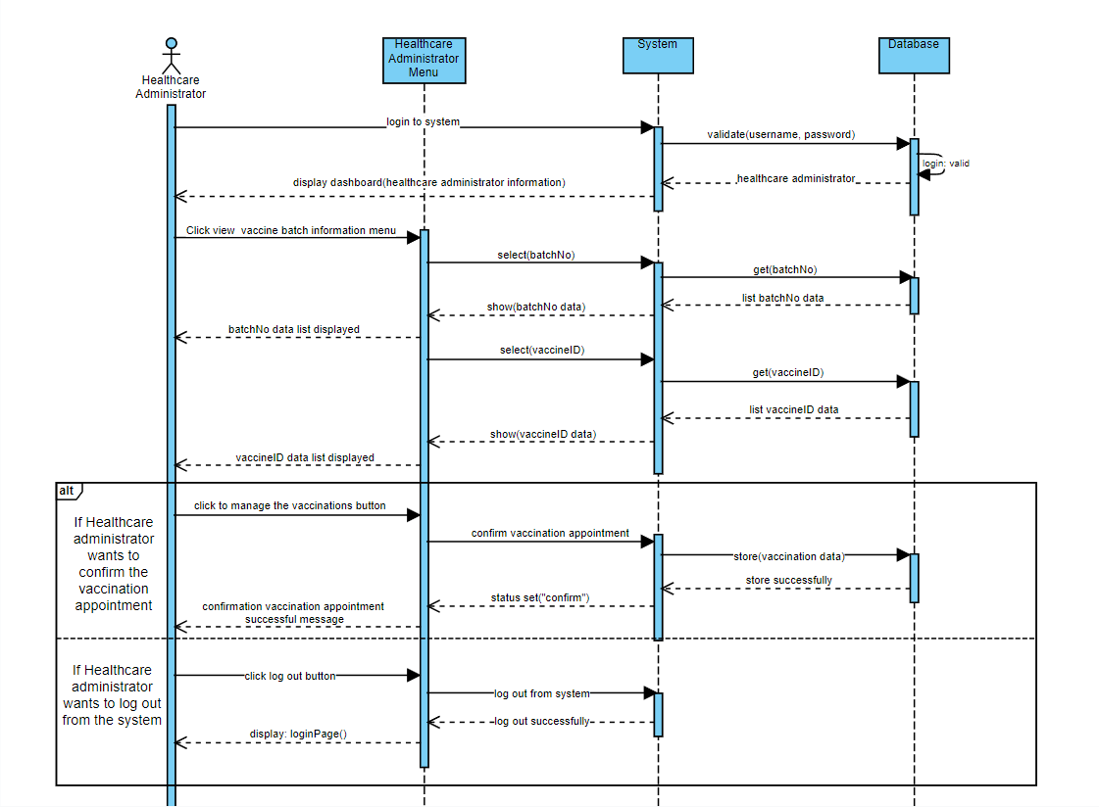

* Contracts

|  |  |
| --- | --- |
| **Cross References** | **View Vaccine Batch Information** |
| Operation | Login(username, password) |
| Responsible | To permit the healthcare administrator to access the healthcare administrator’s dashboard. |
| Pre-conditions | * Healthcare administrator object must be available * Username and Password must be available |
| Post-conditions | * Username and Password is matched or valid * Display healthcare administrator dashboard |
| **Cross References** | **View Vaccine Batch Information** |
| Operation | View Vaccine Batch |
| Responsible | To view the vaccine batch information data |
| Pre-conditions | * Healthcare administrator object must be available * Vaccine batch has been successfully created |
| Post-conditions | * Batch vaccine data list has been found * Batch vaccine data list is correlated with view vaccine batch information menu (association formation) |
| **Cross References** | **View Vaccine Batch Information** |
| Operation | Confirm vaccination appointment |
| Responsible | To confirm vaccination appointment |
| Pre-conditions | * Healthcare administrator object must be available * Vaccination appointment data must be available |
| Post-conditions | * Vaccination appointment status is set to “confirm” * Display successful notification |
| **Cross References** | **View Vaccine Batch Information** |
| Operation | Logout from system |
| Responsible | To logout or exit from the system |
| Pre-conditions | * Healthcare administrator object must be available * Confirm to cancel logout |
| Post-conditions | * Redirect to login page |

### Confirm Vaccination Appointment

* Expanded Use Case

|  |  |  |
| --- | --- | --- |
| **Use Case 7** | Confirm Vaccination Appointment | |
| **Goal** | To confirm a patient’s request for an appointment | |
| **Actor** |  | |
| * **Primary** | Healthcare administrator | |
| * **Secondary** | - | |
| **Trigger** | A healthcare administrator wants to confirm the appointment request. | |
| **Typical Course of Events** | | |
| **Actor Action** | | **System Response** |
| 1. This use case <extend> of use case 6: View Vaccine Batch Information. | |  |
| 1. A vaccinationID is chosen by the healthcare administrator. | | The patient's entire name, IC or passport number, as well as the vaccine's batch number, expiry date, manufacturer, and name, are displayed. |
| 1. The vaccination date is confirmed by the healthcare administrator. | | The status is set to 'confirmed,' and the patient will receive a confirmation email.. |
| **Alternative Course of Events** | | |
| 3a: The healthcare administrator has the option of rejecting the appointment request and leaving comments. The status will be updated to "rejected," and the patient will receive an email with the remarks.. | | |

* SSD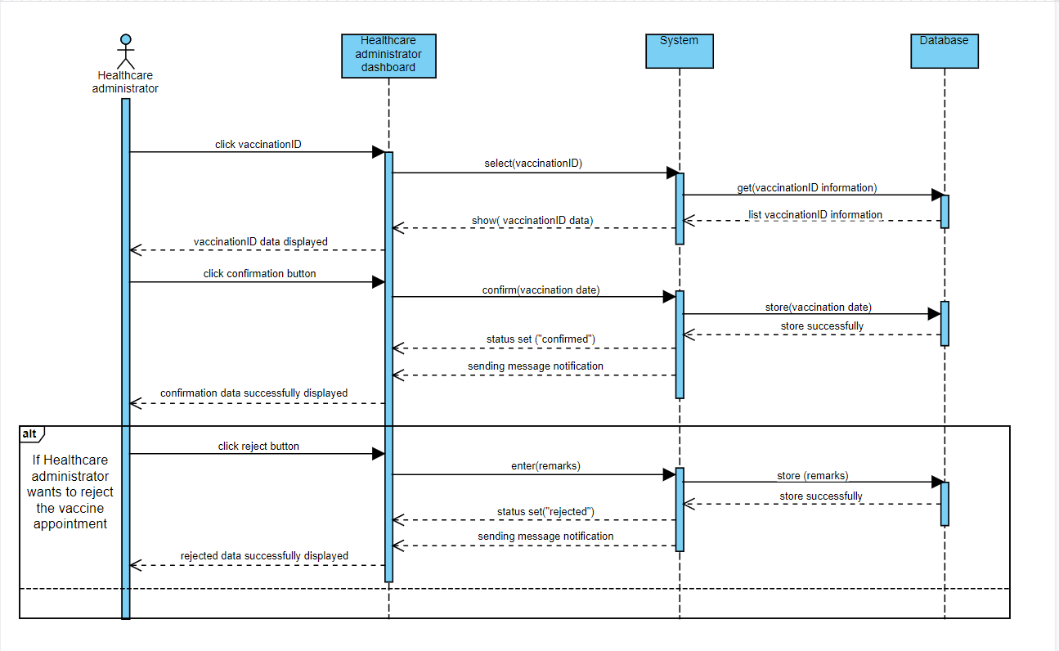
* Contracts

|  |  |
| --- | --- |
| **Cross References** | **Confirm Vaccination Appointment** |
| Operation | Confirm vaccination |
| Responsible | To permit the healthcare administrator to confirm the vaccination appointment |
| Pre-conditions | * Healthcare administrator object must be available * vaccinationID must be available |
| Post-conditions | * New status set to “confirm” * Sending a confirmation message * Display confirmation successful notification message   **IF** Healthcare administrator reject the appointment   * New status set to “rejected” * Sending rejected message * Display rejected notification message |

### Record Vaccination Administered

* Expanded Use Case

|  |  |  |
| --- | --- | --- |
| **Use Case 8** | Record Vaccination Administered | |
| **Goal** | To keep records of when a patient has received a vaccination. | |
| **Actor** |  | |
| * **Primary** | Healthcare administrator | |
| * **Secondary** | - | |
| **Trigger** | The patient has received a vaccination. | |
| **Typical Course of Events** | | |
| **Actor Action** | | **System Response** |
| 1. This use case <extend> of use case 6: View Vaccine Batch Information. | |  |
| 1. A vaccinationID is chosen by the healthcare administrator. | | The patient's entire name, IC or passport number, as well as the vaccine's batch number, expiry date, manufacturer, and name, are displayed. |
| 1. The healthcare administrator verifies that the immunization was given and records any comments. | | The vaccine status is changed to ‘administered’ and the batch's quantity administered is updated. |
| **Alternative Course of Events** | | |
|  | | |

* SSD

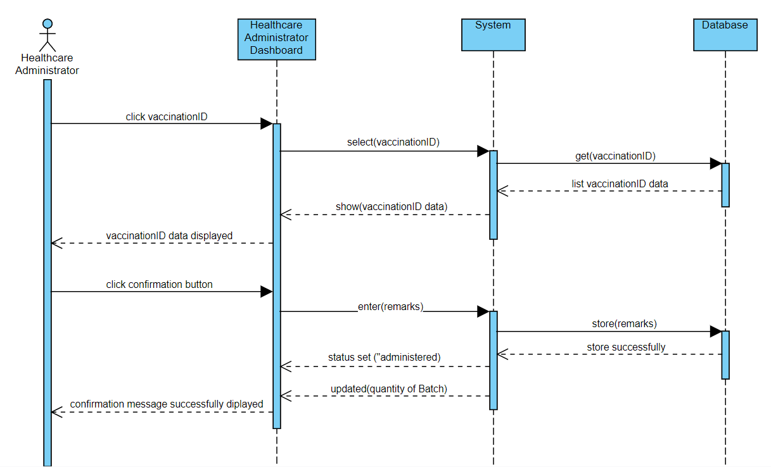

* Contracts

|  |  |
| --- | --- |
| **Cross References** | **Record Vaccination Administered** |
| Operation | Record vaccination |
| Responsible | To record the vaccination that has been administered. |
| Pre-conditions | * Healthcare administrator object must be available * vaccinationID must be available |
| Post-conditions | * New status set to “administered” * New remarks entered * Updating the quantity of Batch * Display confirmation successful message |

# Task Division

|  |  |  |
| --- | --- | --- |
| **Required Behavior** | **Use Case** | **Member In Charge** |
| Structuring site's content using HTML | All use case | All |
| Designing site's appearance using CSS | All use case | All |
| Enhancing site's responsiveness using JavaScript | All use case | All |
| Setting up database using MySQL | All use case | All |
| Enabling user sign up using PHP | Sign up | Zara Athifa |
| Enabling user login using PHP | Login | Zara Athifa |
| Enabling user(patient) to request vaccine appointment using PHP | Request vaccine appointment | Zara Athifa |
| Enabling user(healthcare administrator) to record new vaccine batch using PHP | Record new vaccine batch | Zara Athifa |
| Enabling user(healthcare administrator) to view vaccine information using PHP | View vaccine information | Muthia Kartika |
| Enabling user(healthcare administrator) to record vaccination Administered using PHP | Record vaccination administered | Muthia Kartika |
| Enabling user(healthcare administrator) to confirm vaccination appointment using PHP | Confirm vaccination appointment | Muthia Kartika |
| Enabling user logout using PHP | Logout | Zara Athifa |

# Reference

Editor. (2020, February 12). *Non-functional Requirements: Examples, Types, How to Approach*. AltexSoft. <https://www.altexsoft.com/blog/non-functional-requirements/>

Setiawan, R. (2021, August 3). *Apa Itu Sequence Diagram dan Contohnya*. Dicoding Blog. <https://www.dicoding.com/blog/apa-itu-sequence-diagram/>